Q1. Query to find All the information about each product.

Ans**: db.Products.find()**

Reference Screenshot:

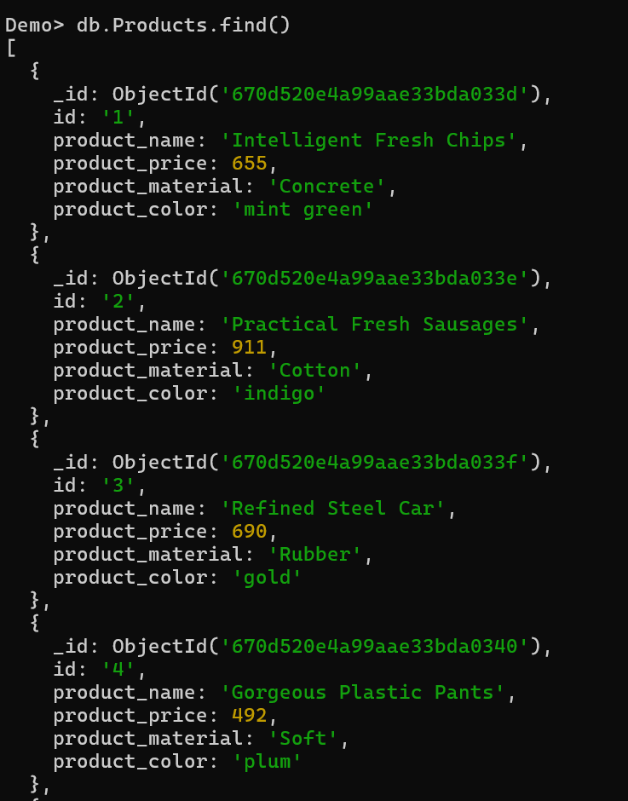

Q2. Find the product price which are between 400 to 800

Ans: **db.Products.find({product_price:{$gte:400,$lte:800}})**

**Output:**

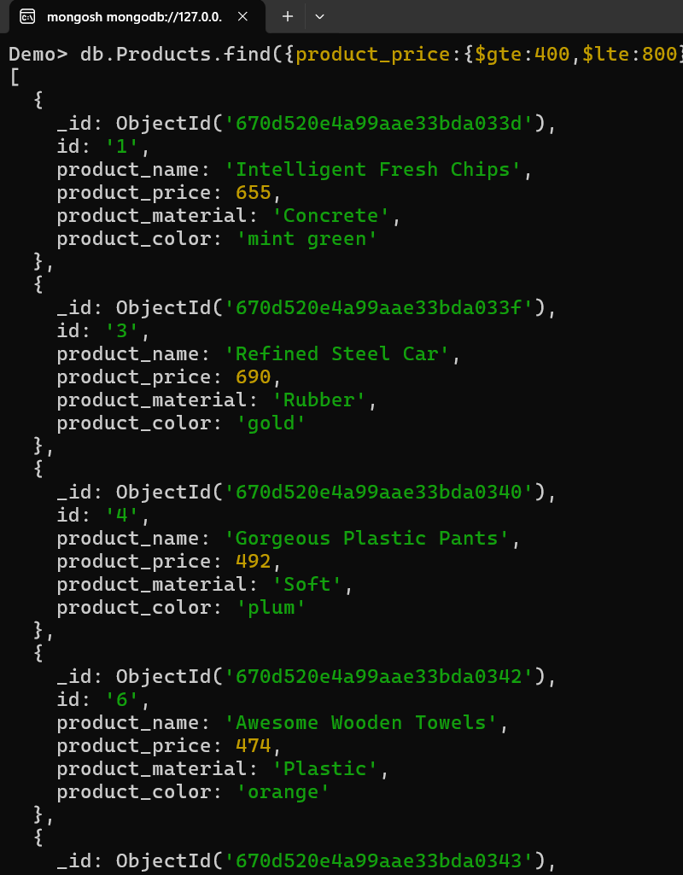

Q3. Find the Products price which are not between 400 to 600

Ans: **db.Products.find({product_price:{$lte:400,$gte:600}})**

**Output**

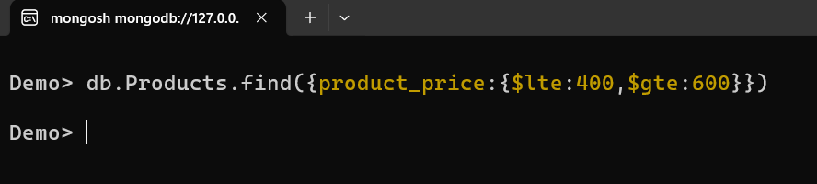

Q4. List 4 products which are greater than 500 in price

Ans: **db.Products.find({product_price:{$gte:500}}).limit(4)**

**Output**

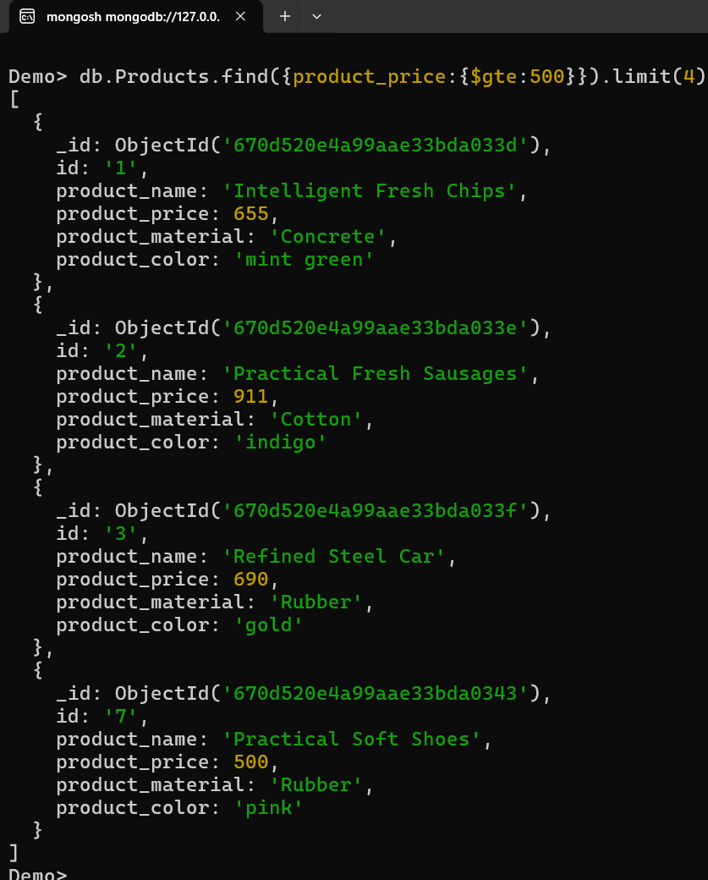

Q5. Find the product name and product material of each products

Ans: **db.Products.find({},{product_name:1,product_material:1})**

**Output:**

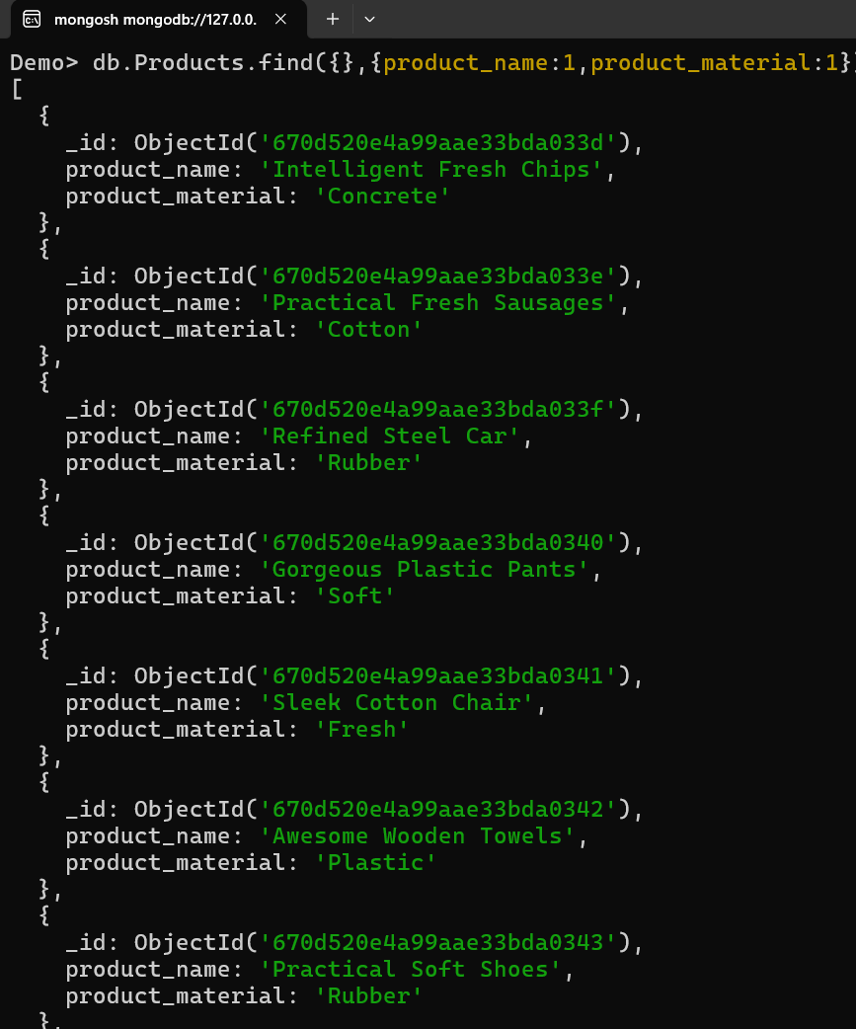

Q6. Find the product with rowID 10

Ans: **db.Products.find({id:{$eq:'10'}})**

**Output**

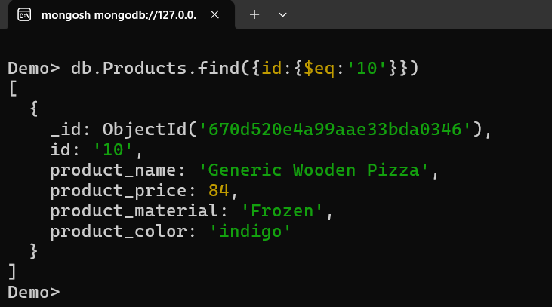

Q7. Find Only the product name and Product material

Ans: **db.Products.find({},{product_name:1,product_material:1})**

Output:

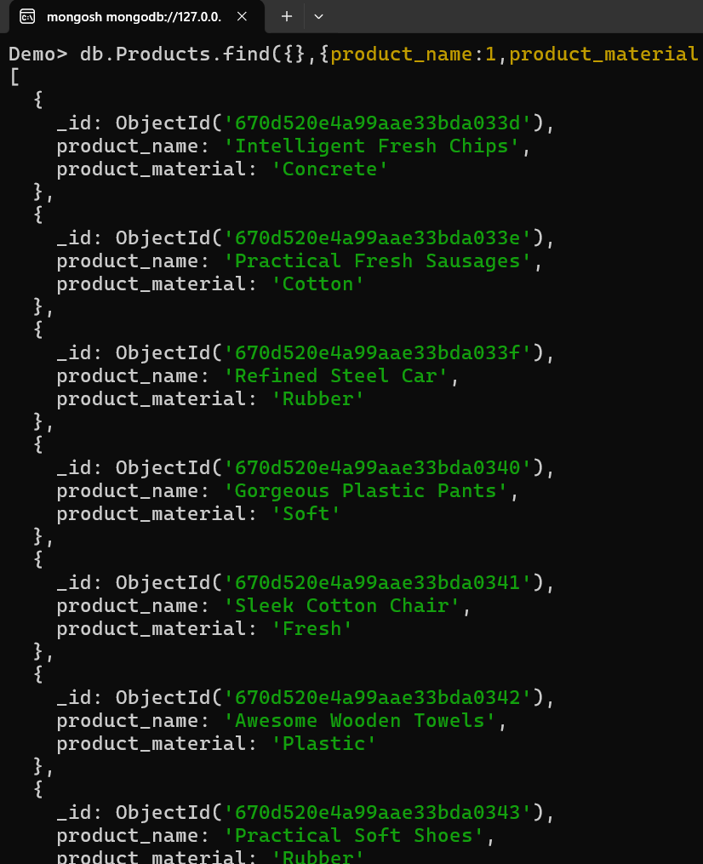

Q8. Find All the products which contains the value of soft in Product material

Ans: **db.Products.find({product_material:{$regex:/soft/, $options:'i'}})**

Output

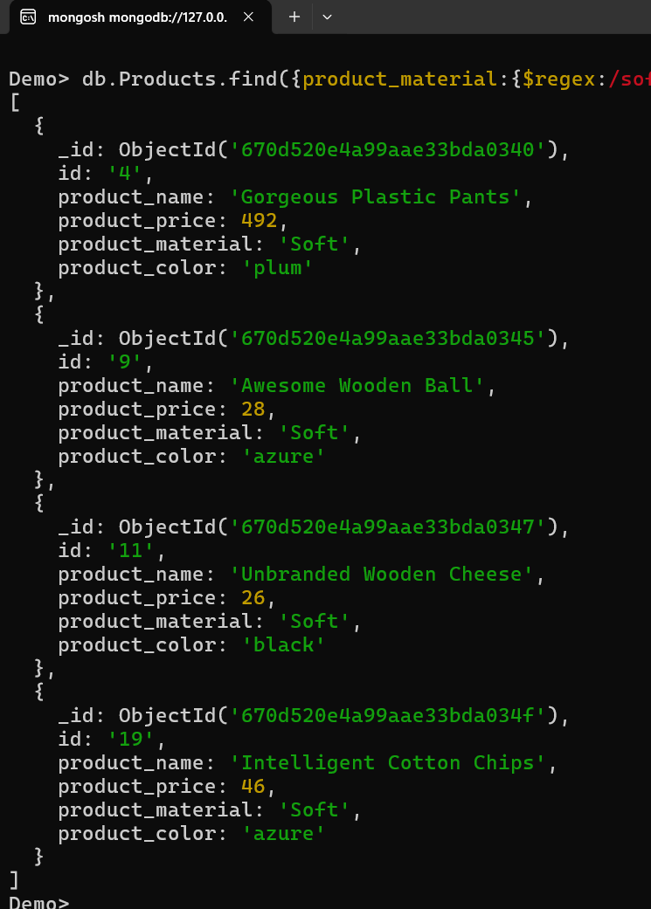

Q9. Find the products that contain product color INDIGO and product price 492.00

Ans: **db.Products.find({$or:[{product_color:{$eq:'indigo'}},{product_price:{$eq:492}}]})**

Output

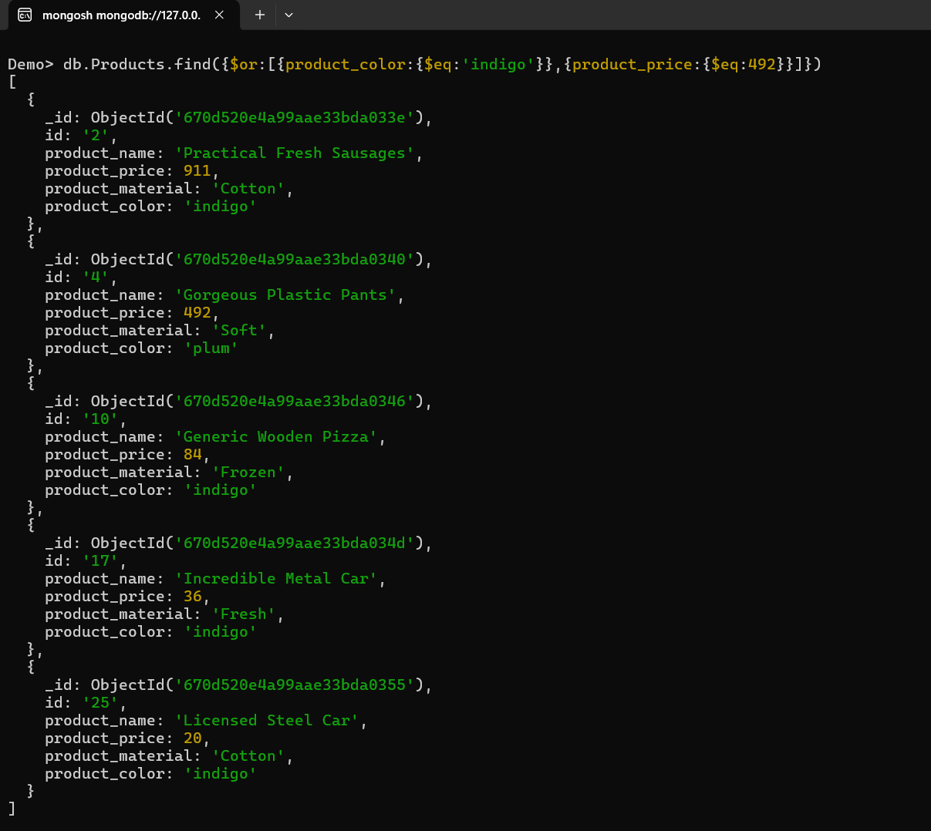

Q10. Delete The Products which product price value are 28

Ans: **db.Products.deleteMany({product_price:{$eq:28}})**

Output

